**Unit 4 – Multiply Whole Numbers and Decimals**

**STUDY BUDDY**

Name: _______________________________________________ Date ______________________ AM / PM

 5.NBT.5 - Fluently multiply multi-digit whole numbers. E M WT WS NP

73 x 68 = ___________________ 549 x 56 = _____________________ 217 x 8 = ___________________

Exceeds Target: Write your own multiplication story problem using a real world situation that involves 2 or 3 digit numbers. Solve the problem accurately. You may use additional paper if needed.

◉ 5.NBT.7.a - Multiply decimals to hundredths. E M WT WS NP

36.3 x 4.7 = ________________ 9.2 x 0.35 = _____________________ 8.76 x 1.4 = _________________________

Exceeds Target: Write a different multiplication story problem using a real world situation that involves 2 or 3 digit numbers. At least one number must be a decimal. Solve the problem accurately. You may use additional paper if needed.

◉ 5.NBT.7.b - Relate the strategy to a written method and explain the reasoning used. E M WT WS NP

Is this problem correct? If not, explain what they did wrong and show how you could solve it correctly.

57.2 x 2.62 = 1498.64

Solve this problem 9.6 x 0.52 and explain how you know your answer is correct.

Exceeds Target: Solve this problem using both the partial products algorithm and the standard algorithm. Explain the similarities and differences between the two methods.

|  |  |
| --- | --- |
| **Standard Algorithm** | **Partial Products** |
| 728 x 31 = _________________ | 728 x 31 = _________________ |
| **Similarities** | **Differences** |
|  |  |

**MAY USE CALCULATOR FOR 5.MD.1**

◉ 5.MD.1 - Convert among different-sized standard measurement units within a given measurement system (e.g., convert 5 cm to 0.05 m), and use these conversions in solving multi-step, real world problems. E M WT WS NP

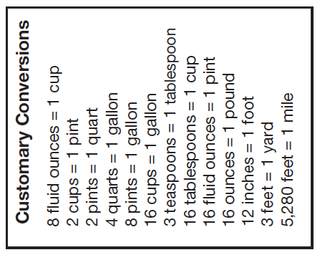

1 meter = 100 centimeters

1 centimeter = 10 millimeters

A baseball player hit the ball 47 yards. How many inches is that?

_____________________

Kristy threw her plane 5.7 meters.

How many millimeters is this? _______________

How many centimeters is this? _____________________

Exceeds Target: In a soup recipe it asks for 3 tablespoons of paprika. If you were cooking for our whole class, you would need to make 9 batches of soup. How many cups of paprika do you need for all of the batches required? _________________________

Grading – NO MULTIPLICATION CHART FOR THIS TEST

For each standard:

**Meets** if they had only 1 silly mistake (addition error, not a multiplication or decimal error).

**Working towards** if they had 1 or more major mistakes.

**Working towards with support** if they had support with instruction or on the

assessment in order to complete some of the problems successfully (use best judgment).

**No progress** is made even with extra instructional support. They missed almost all of the problems and had extra instruction).