Unit 5 – Classifying 2D Figures
STUDY BUDDY

Name: _______________________________________________ Date ______________________ AM / PM

5.G.3 - Understand that properties belonging to a category of two-dimensional figures also belong to all subcategories of that category. For example, all rectangles have four right angles and squares are rectangles, so all squares have four right angles.
E M WT WS NP
1. The teacher asked her class to draw a rhombus. Student 1 drew a parallelogram, Student 2 drew a square, and Student 3 drew a rectangle. Which students were correct? __________________________________
Explain your answer below.

2. My friend drew a shape that she said was a rectangle. The teacher said that it was not a rectangle. How can my friend check to see if it is?

3. Write all the names this shape could have. Circle the most specific name for this shape.
_________________________
_________________________
_________________________
_________________________
_________________________
_________________________

Exceeds Target: What’s the sum of the interior angle measures of any pentagon? Explain how you know. ______________________________

5.G.4. Classify two-dimensional figures in a hierarchy based on properties.
E M WT WS NP

There is a mistake in this hierarchy. Fix it and then draw each shape next to the name.

Exceeds Target: Where would you put a rhombus in the hierarchy? Draw it in and explain why you put it there.

Exceeds Target: Give a reason why you placed each shape (ALL 6) in its location.

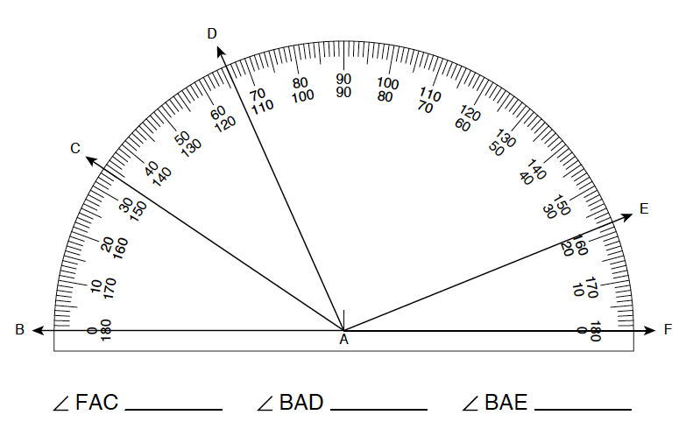

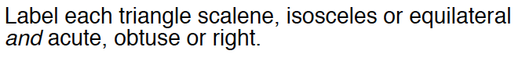
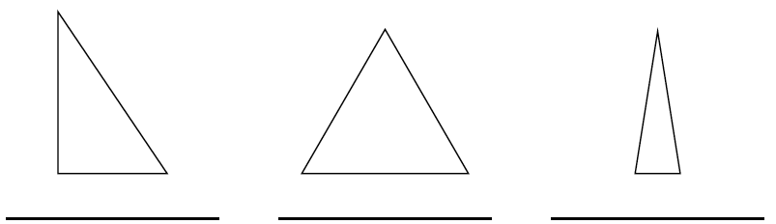

Grading-All 100% correct on both pages to MEET the learning target.

- Wrote something about 2 pairs of parallel lines.
- Wrote about both right angles and equal length sides.
- Triangle – check only polygon
Diamond – check polygon, quadrilateral, parallelogram, and rhombus

Hierarchy: Polygon

Quadrilateral Triangle

Parallelogram

Rectangle

Square

Exceeds- The rhombus belongs next to the rectangle because it is a type of parallelogram, but it doesn’t have to have right angles. It may or may not be attached to the square to receive the exceeds.

Exceeds- The polygon belongs at the top because it includes all shapes that do not intersect, have curves, or have gaps. The quadrilateral goes under the polygon because it is a type of polygon that has four sides. The triangle belongs next to the quadrilateral because it is a type of polygon that has three sides. Under the quadrilateral is the parallelogram because it is a shape that has 2 pairs of parallel lines, so it is a type of quadrilateral since it must have four sides. A rectangle is a special type of parallelogram because all the opposite sides must be parallel and it has to have right angles. The square belongs under the rectangle because it is a special type of rectangle that must include all equal sides and have right angles.

