5.MD.5a. Find the volume of a right rectangular prism with whole-number side lengths by packing it with unit cubes, and show that the volume is the same as would be found by multiplying the edge lengths, equivalently by multiplying the height by the area of the base. Represent threefold whole-number products as volumes, e.g., to represent the associative property of multiplication.
5.MD.5b. Apply the formulas V = l × w × h and V = b × h for rectangular prisms to find volumes of right rectangular prisms with whole-number edge lengths in the context of solving real world and mathematical problems.

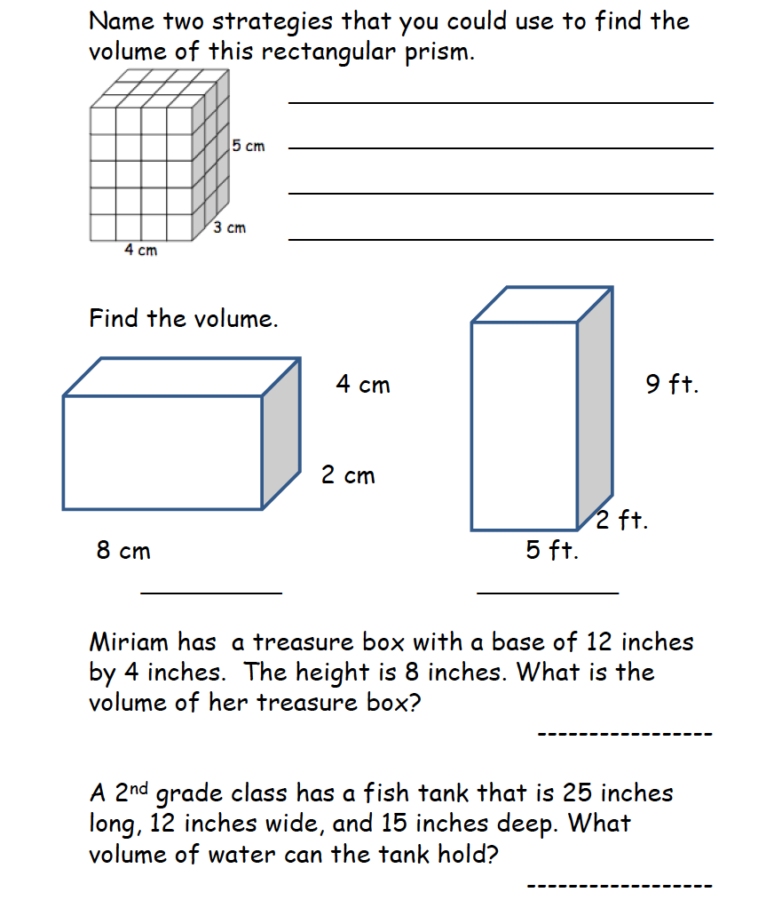

5.MD.5c Recognize volume as additive. Find volumes of solid figures composed of two non-overlapping right rectangular prisms by adding the volumes of the non-overlapping parts, applying this technique to solve real world problems.

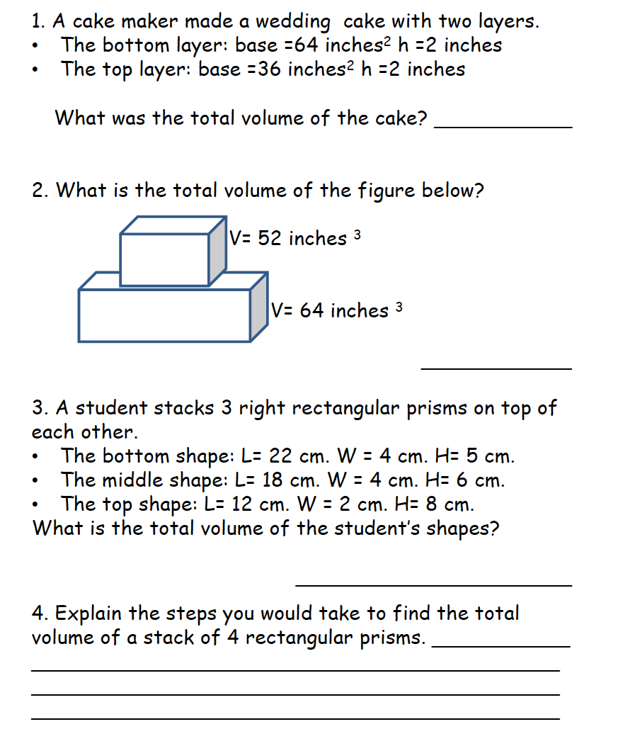

5.OA.2 Write simple expressions that record calculations with numbers, and interpret numerical expressions without evaluating them.

