Unit 7 – Study Buddy

Name: _______________________________________________ Date ______________________ AM / PM

5.NBT.6a I can divide four-digit numbers by two-digit numbers to find a whole number quotient without remainders (using equations, area model, arrays, etc.) E M W WS NP
Solve:
$712 ÷ 8=$ $1067 ÷ 11=$ $1305 ÷ 15=$

5.NBT6b. - I can illustrate and explain the calculations by using equations, rectangular arrays and/or area models.
E M W WS NP
DIRECTIONS: This problem has been solved for you. Is this solution right or wrong? Show how you could check to see if this problem is correct or not without using division.

$$510÷15=32$$

DIRECTIONS: The problem below has been solved for you. Show how you could use a rectangular array or area model to know if the answer is correct.
$$27 ÷3=9$$

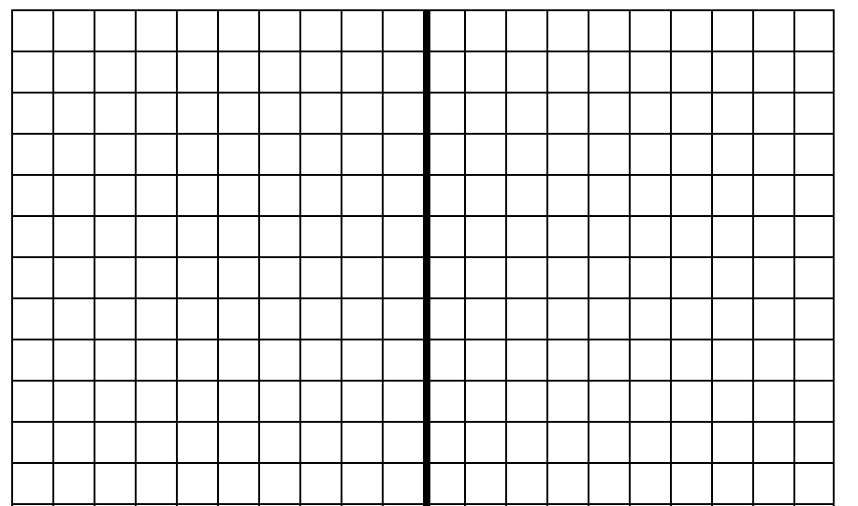

5.NBT.7 - I can divide decimals to the hundredths, using concrete models or other strategies to solve problems and explain the reasoning used. E M W WS NP

Solve: 2.8 ÷ 0.7 = _________________

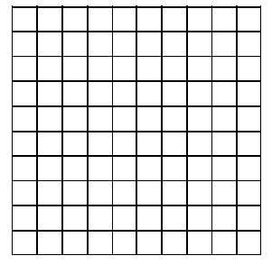

20.8 ÷ 4 = __________________

5.MD.1 - I can convert between measures in a given system and use these conversions in solving multi-step, real world problems. E M W WS NP
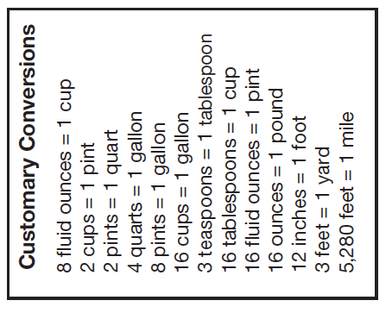
Sara was building a fence. She needed a board that was 2.5 yards long.
How many inches is that? _______________________________

Henry was making cookies. The recipe called for 3.5 cups of flour.
How many pints is that? _____________________________

25.3 cm = ________________________m

3.2 gallons = ____________________________ cups

4.56 m = _______________________________mm

14 quarts = ______________________________ gallons, _______________ pints, ______________________ cups

142 mm = __________________________________cm

